**1**

**SK DOSEN PENGAMPU MATAKULIAH**

**PRODI D2 PERAWATAN MESIN PENGOLAH HASIL PERKEBUNAN**

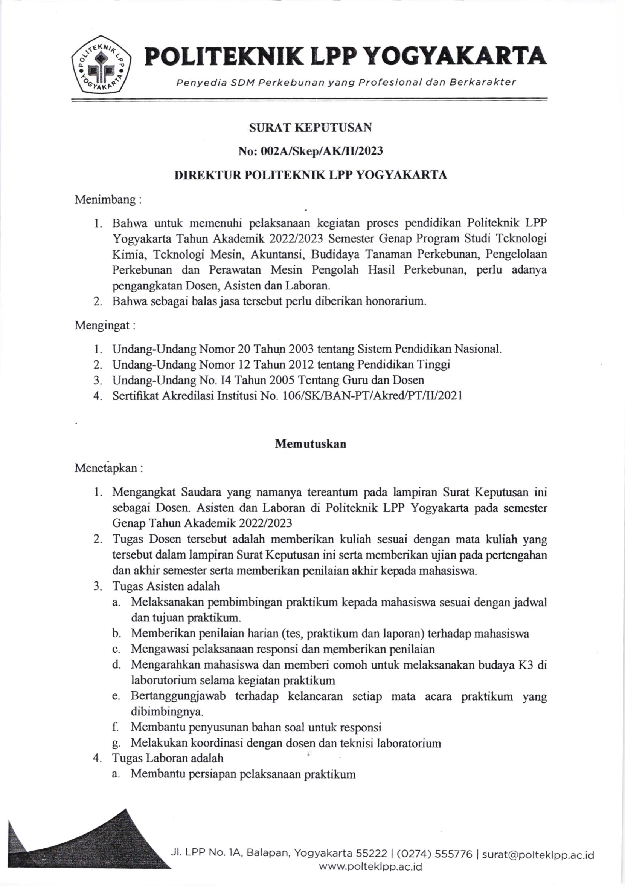

**2**

**JURNAL MATAKULIAH PERALATAN PEMINDAH DAYA MEKANIK**

**KELAS BLU**

**PRODI D2 PERAWATAN MESIN PENGOLAH HASIL PERKEBUNAN**

**3**

**PRESENSI MAHASISWA MATAKULIAH PERALATAN PEMINDAH DAYA MEKANIK**

**KELAS BLU**

**PRODI D2 PERAWATAN MESIN PENGOLAH HASIL PERKEBUNAN**

**4**

**NILAI MATAKULIAH PERALATAN PEMINDAH DAYA MEKANIK**

**KELAS BLU**

**PRODI D2 PERAWATAN MESIN PENGOLAH HASIL PERKEBUNAN**

